**PROJECT REPORT ON**

**Building An Employee Travel Approval**

**Application For Corporates**

**Developer – (Long term)**

**Skills Required:**

Salesforce Developer

**Project Description:**

This project provides real-time knowledge for all the students who have basic knowledge of Salesforce and looking for a real-time project. This project will also help those professionals who are in cross-technology and want to switch to Salesforce. With The help of this project they will gain knowledge and can include it into their resume as well.

**Aim:**

**“**To build an employee travel approval application for corporates”

**Creating a Salesforce Developer Org**

1. Search Developer.salesforce.com/signup

2. Enter the following details like First name, last name, Email, Role, Company, Country/Region, Postal code, and Username must be unique

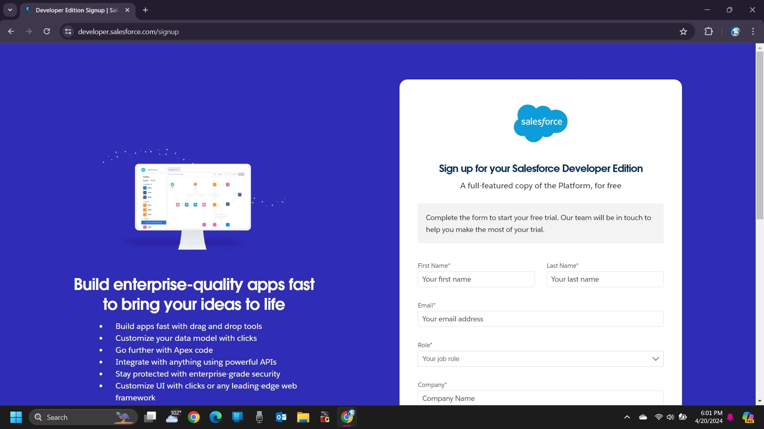

3. Click sign me up, after a few min you will reserve a mail salesforce Org and by using the verify account link you can create your new Password

4. Click save.

5. Search login.salesforce.com

6. By using username and password you can into the Salesforce org

**Create Department Object :**

1. Click on the gear icon and then select Setup.

2. Click on the object manager tab just beside the home tab.

3. After the above steps, have a look on the extreme right you will find a Create Dropdown click on that and select Custom Object.

4. On the Custom Object Definition page, create the object as follows:

5. Label: Department

6. Plural Label: Departments

7. Record Name: Department Name

8. Check the Allow Reports checkbox

9. Check the Allow Search checkbox

10. Click Save.

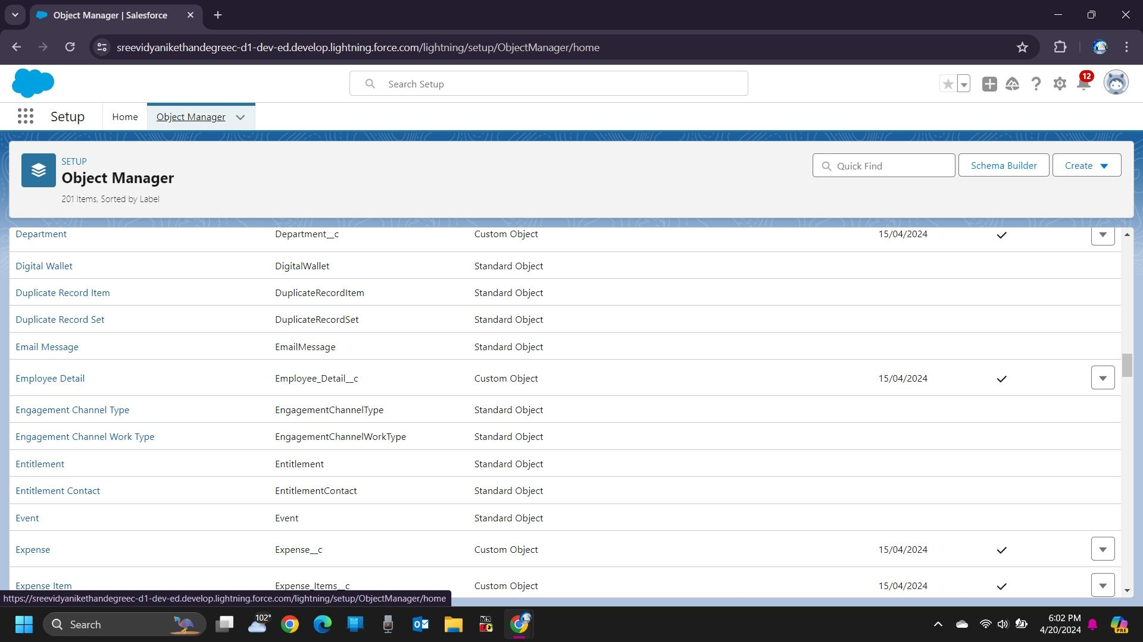

### **Custom Tab Creation**

1. Enter Tabs in Quick Find and select Tabs.

2. Under Custom Object Tabs, click New.

3. For Object, select Department.

4. For Tab Style, select any icon.

5. Leave all defaults as is. Click Next, Next, and Save

6. In the same way create Tabs for all Custom Objects – Employee Detail, Expense, Expense Items, and Travel Approval.

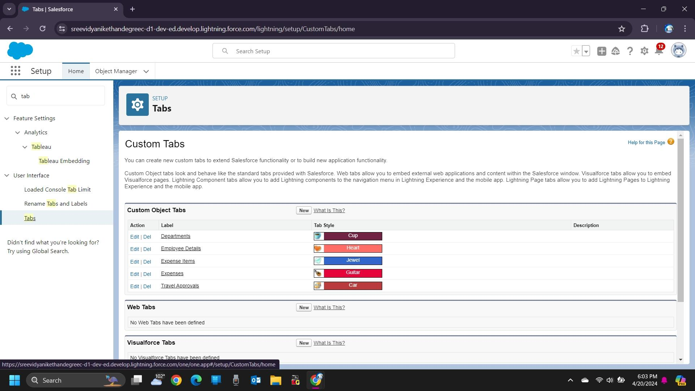

**Create Travel Approval App**

1. From Setup, enter App Manager in the Quick Find and select App Manager.
2. Click New Lightning App.
3. Enter Travel Approval as the App Name, then click Next
4. Under App Options, leave the default selections and click Next.
5. Under Utility Items, leave as is and click Next.
6. From Available Items, select Department, Employee Detail, Expense, Expense Items, Travel Approval, Reports, and Dashboards and move them to Selected Items. Click Next.
7. From Available Profiles, select System Administrator and move it to Selected Profiles. Click Save & Finish

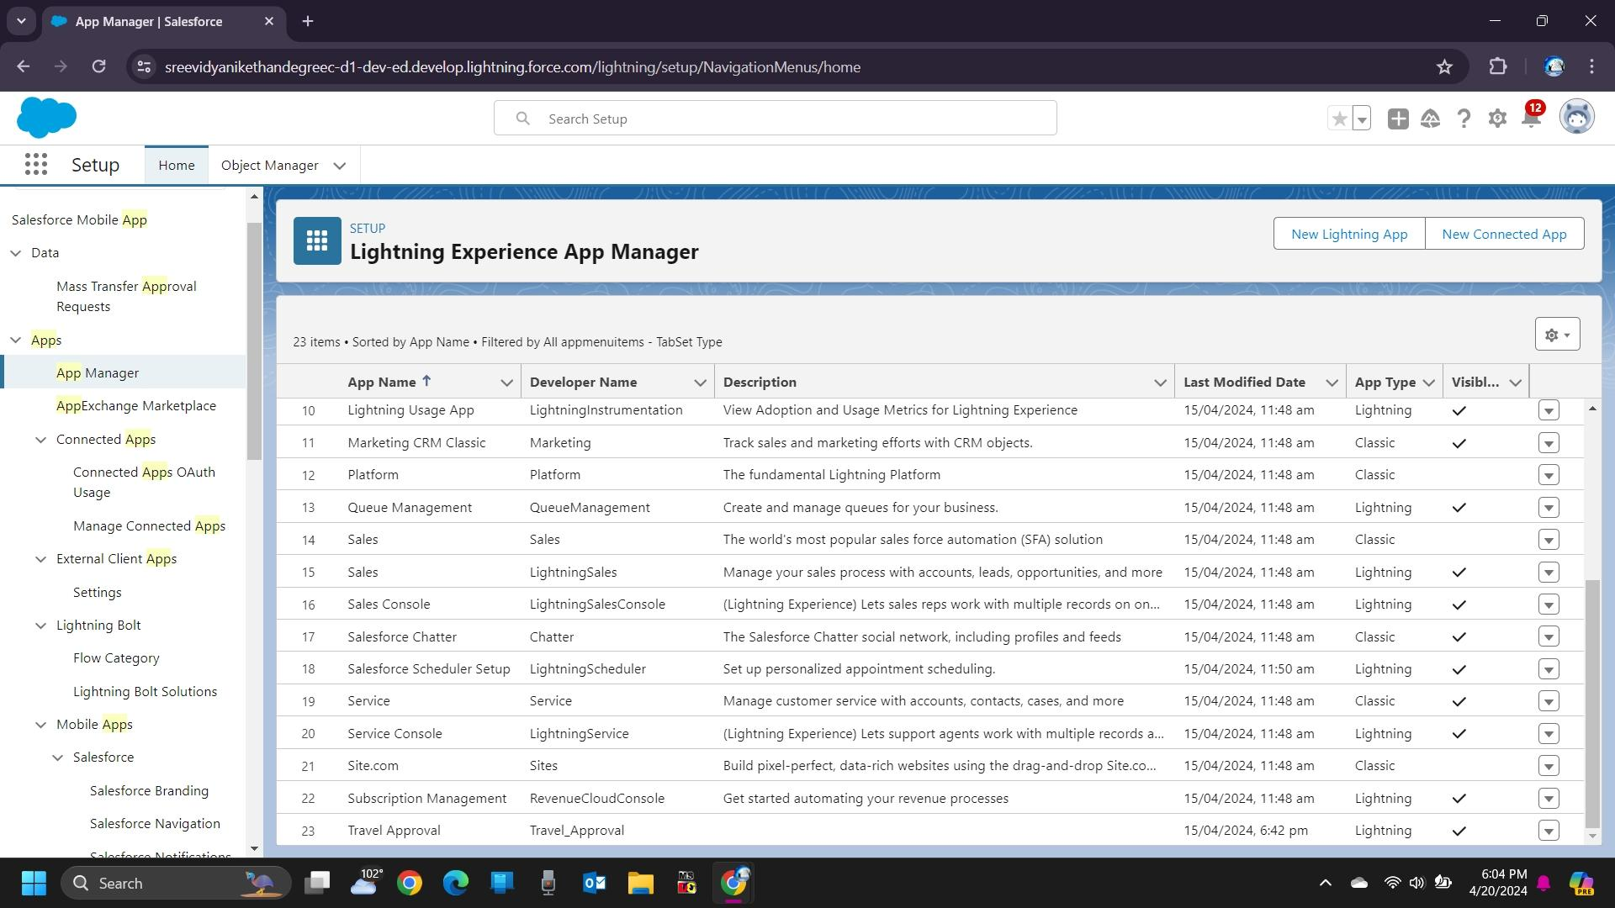

### **Creation Of Fields For The Department Object:**

1.Click the gear icon and select Setup. This launches Setup in a new tab.

2.Click the Object Manager tab next to Home.

3.Select Department

4.Select Fields & Relationships from the left navigation

5.Click New

6.Select the Text as the Data Type, click Next.

7.For Field Label, enter Department Code and enter 5 in Length.

8.Click Next, Next, then Save & New.

9.Follow above steps and create two more Text type field – District & State.

10.Also, Provide Length 40 for both District and State field.

11.Create URL type field & give “School website” as the field label.

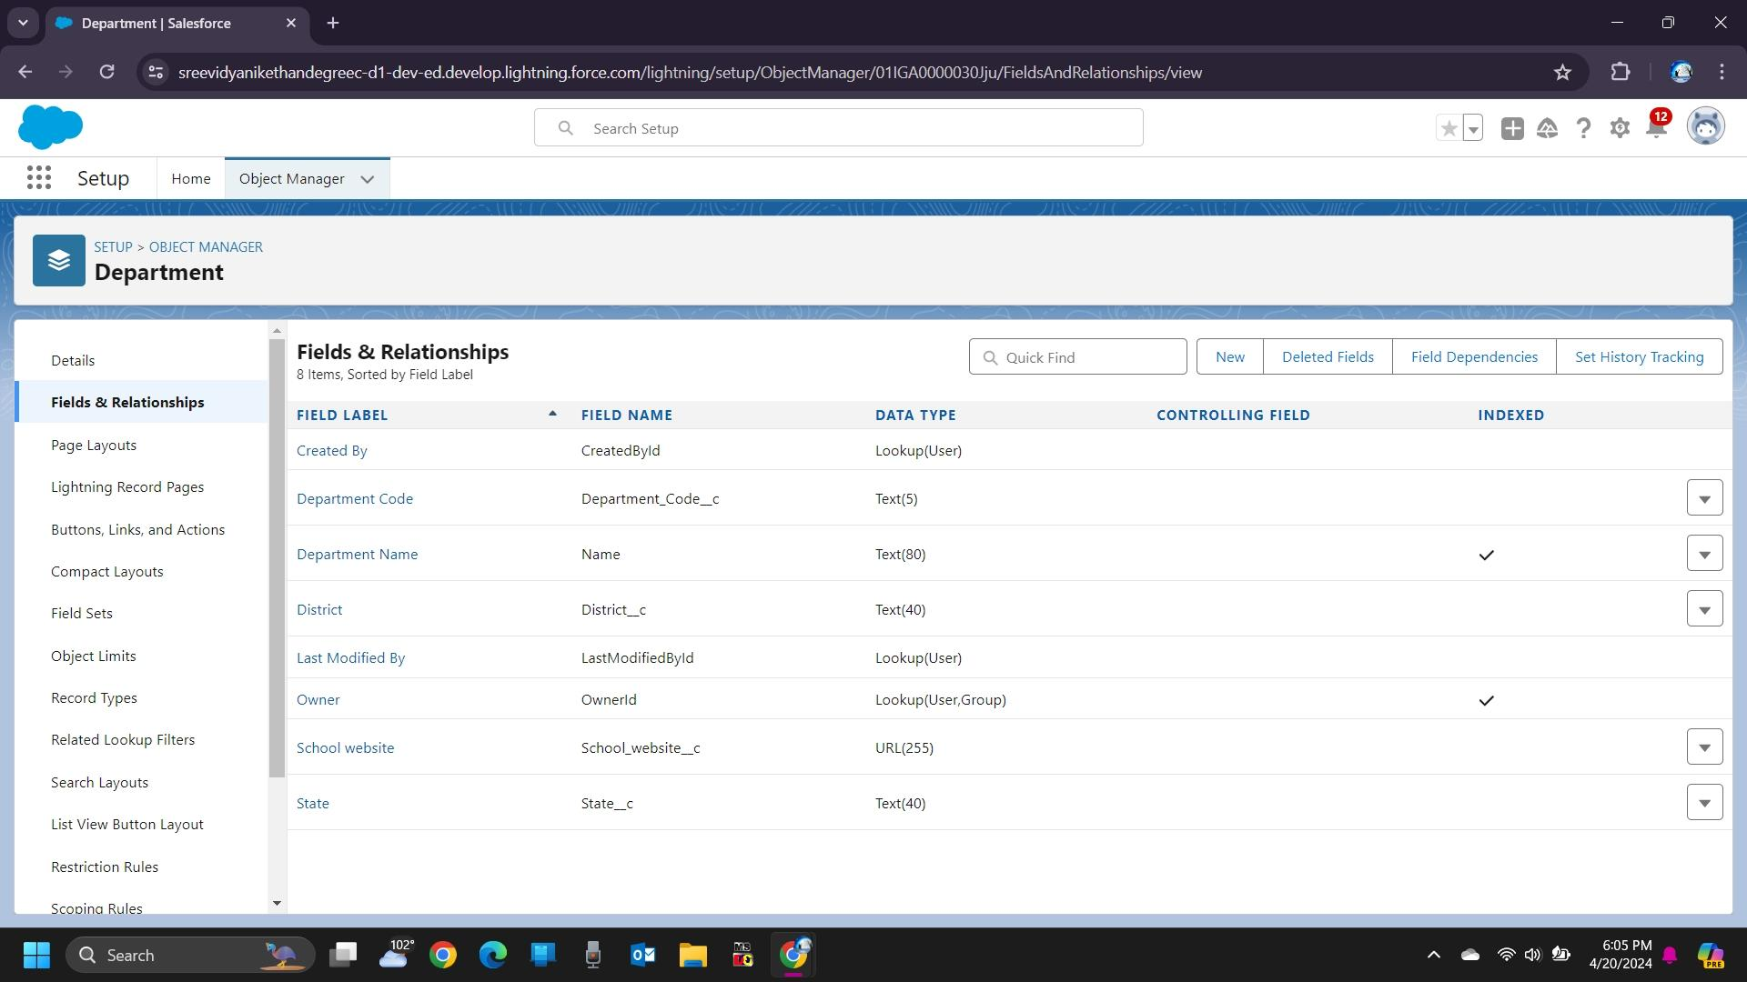

**Lookup Relationship With Department**

Let’s create a Lookup relationship with Department object on Employee Detail object Follow steps 1 to 5 of field creation then follow below steps.

1. Select look up Relationship as the Data Type and click Next.
2. For Related to, enter Department.
3. Click Next.
4. For Field Label, enter Department.
5. Click Next, Next, Next and Save.

Let’s create a master-detail relationship on Expense Item object Follow steps 1 to 5 of field creation then follow below steps.

1. Select Master-Detail Relationship as the Data Type and click Next.
2. For Related to, enter Expense.
3. Click Next.
4. For Field Label, enter Expense.
5. Click Next, Next, Next and Save.

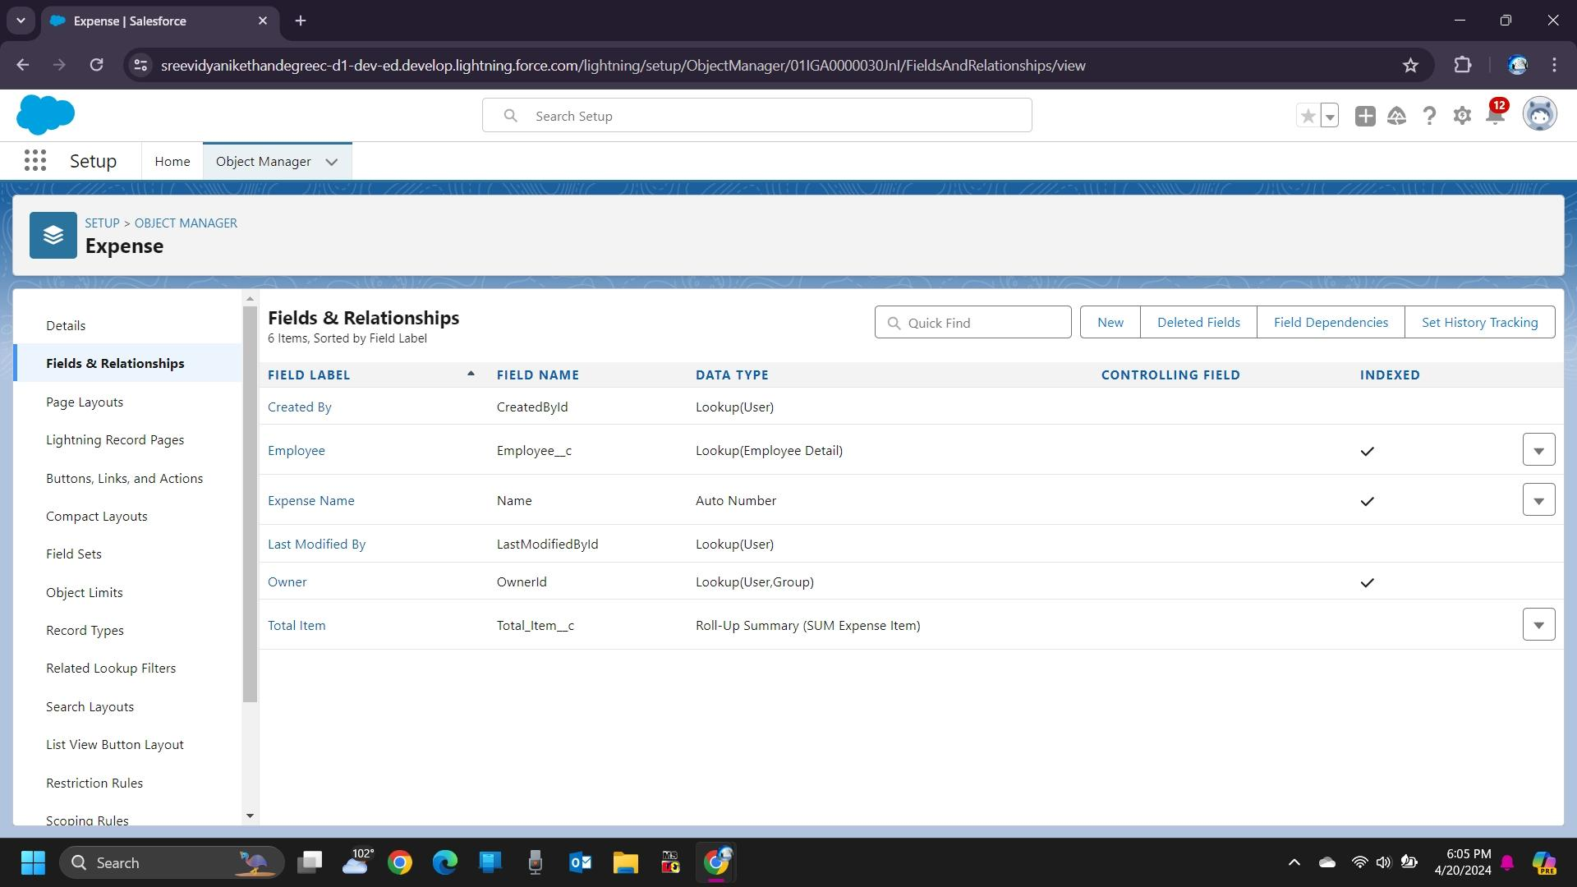

**Roll Up Summary Fields On Expense Object**

Let’s create Roll-up summary fields on Expense Object to calculate the expense

1. Click the gear icon Select Setup, This launches Setup in a new tab.
2. click Object Manager
3. Select Expense.
4. Click Fields & Relationships
5. Click New.
6. Select the Roll-up summary field as the data type
7. Enter the field label as Total Expense
8. Click Next
9. Then select the master object summarized as Expense items
10. Select Sum as roll-up and Field to aggregate Amount then click Next, Next and save.

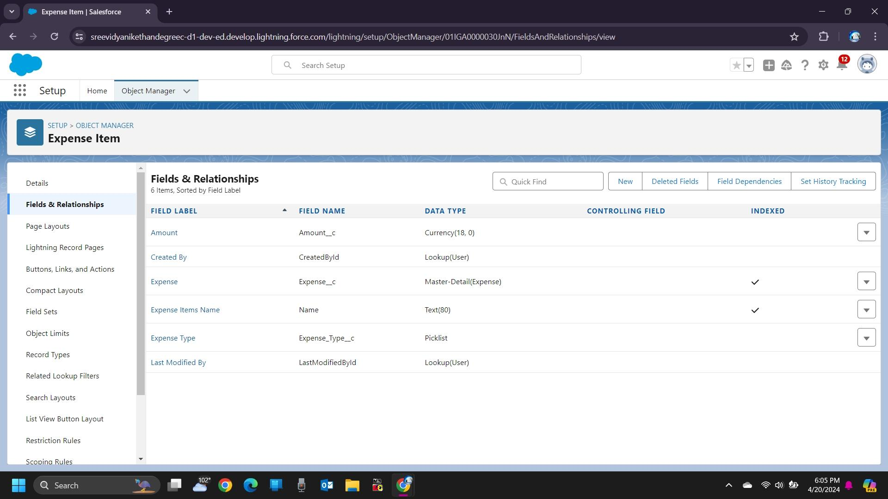

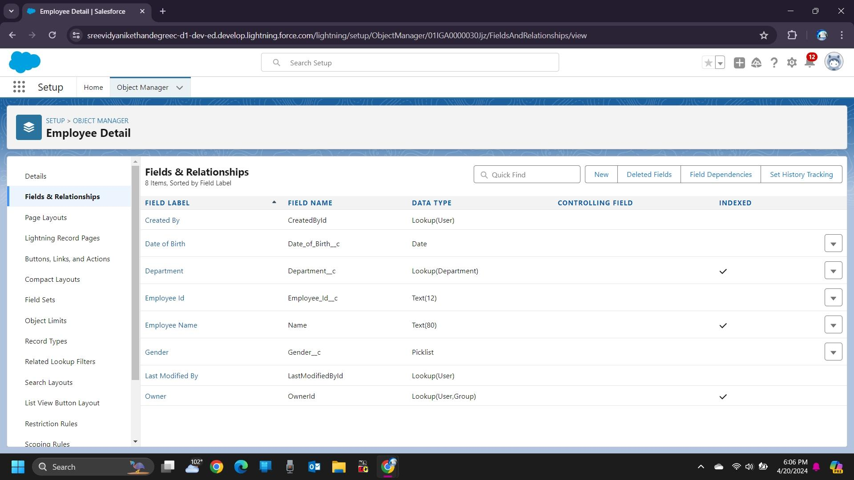

**Pick List Field**

Let’s create a Pick-List field:

1) From Setup, click Object Manager and select Expense Item.

2)Click Fields & Relationships, then New.

3)Select Picklist as the Data Type and click Next.

4)For Field Label enter Expense Type

5)Select Enter values, with each value separated by a new line, and enter these values:

Transport

Hotel

Meal

6)Click Next, Next, then Save & New

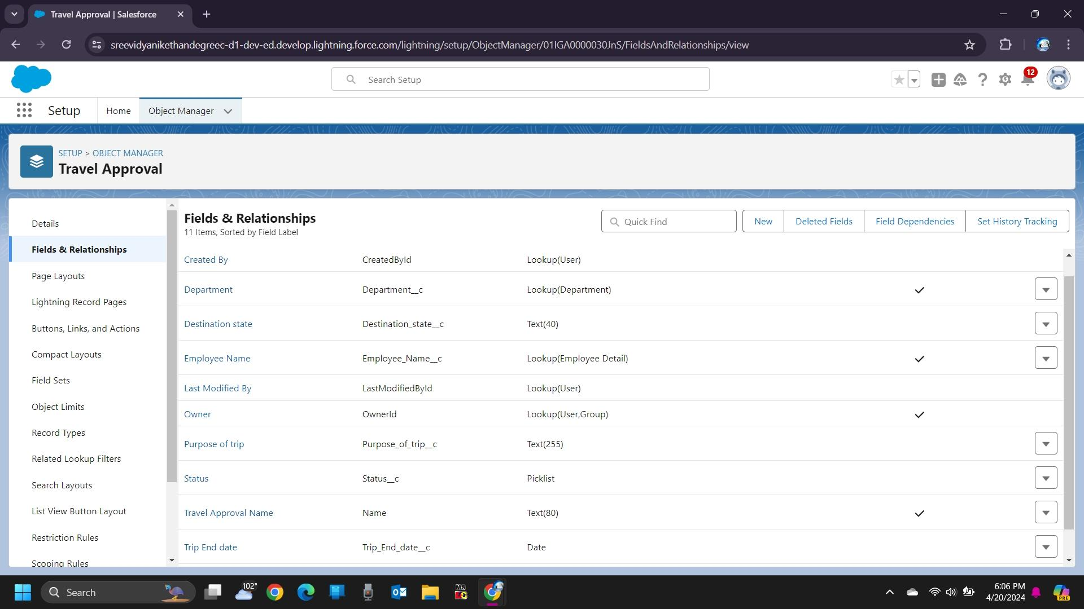

### **Data Import**

From Setup, click the Home tab.

1)In the Quick Find box, enter Data Import and select Data Import Wizard.

2)Click Launch Wizard!

3)Click the Custom Objects tab and select the Departments object.

4)Select Add new records.

5)Click CSV and choose file Department_CSV which we made earlier. Click Next.

6)Since the field names in the CSV file (CSV Header) are the same as the field names in your object (Mapped Salesforce Object), the fields are automatically mapped. Click Next.

The next screen gives you a summary of your data import. Click Start Import.

Click OK on the popup**.**

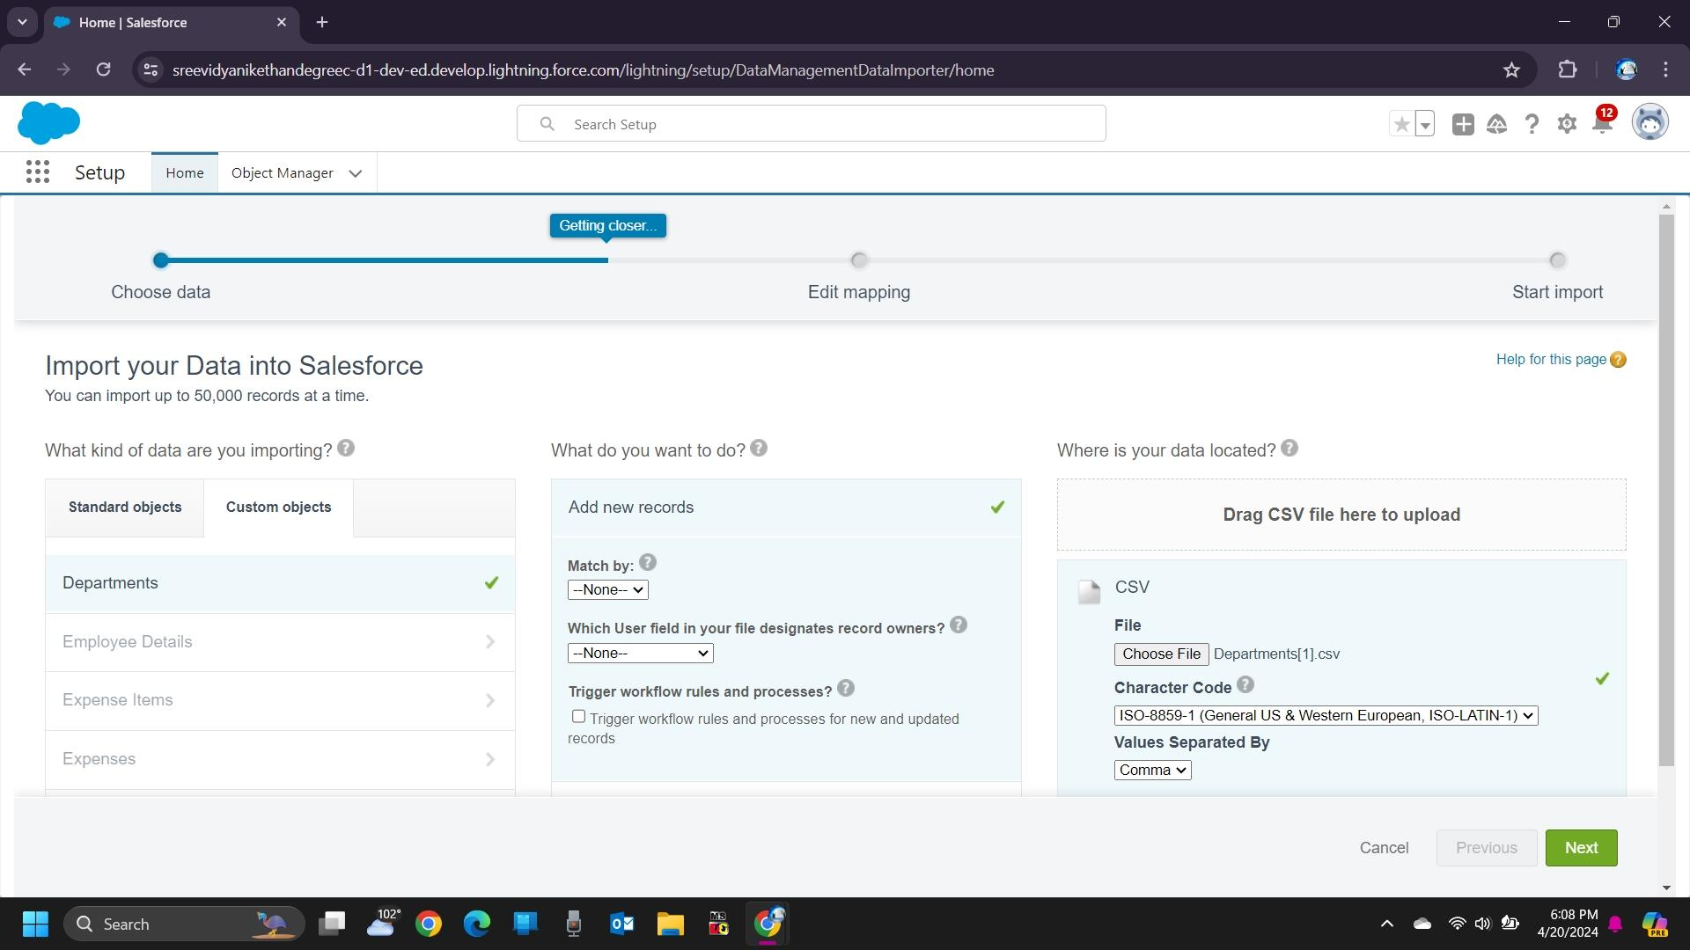

**Creating A User In Salesforce**

1.From Setup, in the Quick Find box, enter Users.

2.Select Users.

3.Click New User.

4.Enter the First Name Travel Approval and Last Name manager and (Your) email address and a unique username in the

Form of an email address. By default, the username is the same as the email address.

5.Select a User License as Salesforce.

6.Select a profile as Standard user.

7.Check Generate new password and notify the user immediately to have the user’s login name and a temporary password

Emailed to your email

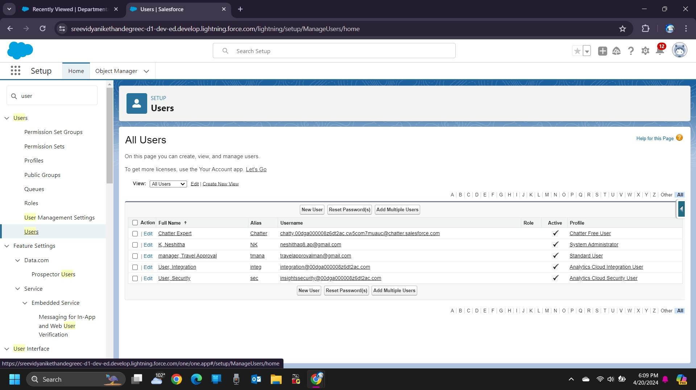

### **Customize Travel Approval Object Page Layout**

1. From the Object Manager, search for the Travel approval object

2. click on page layouts and click Travel Approval Layout

3. Drag the Section from the top pane to the lower pane directly below the Information section. When dragging over the

Page, you get a visual indicator of where you can drop the new section.

4. Name the section Trip Info, leave the rest of the settings at their default values, and

5. Then click on OK.

6. Drag Trip Start Date and Trip End Date, Status from the top pane into the left-hand column of the Trip Info Section.

7.Drag the Destination State and Purpose of a trip from, department the top pane into the right-hand column of the Trip

8.Click Save.

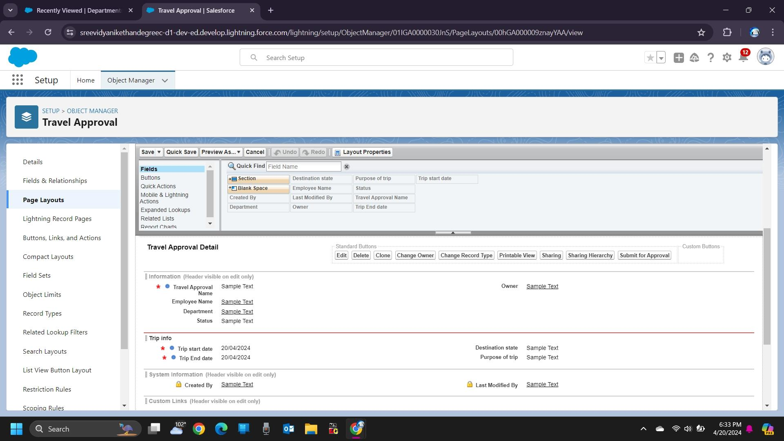

**Create Validation Rule**

Search for the travel approval object from the object manager and open the object.

1)Click on validation rules and click new on the left corner

2)Give your rule name Date _Validation and make sure that the rule is set to active.

3)In the error condition formula enter Trip_End_Date c < Trip_Start_Date c

NOTE- Make sure that there is no syntax error after you input this error condition

Give the Error message – “Trip end date must be the date greater than the Trip start date” &

4) Click save

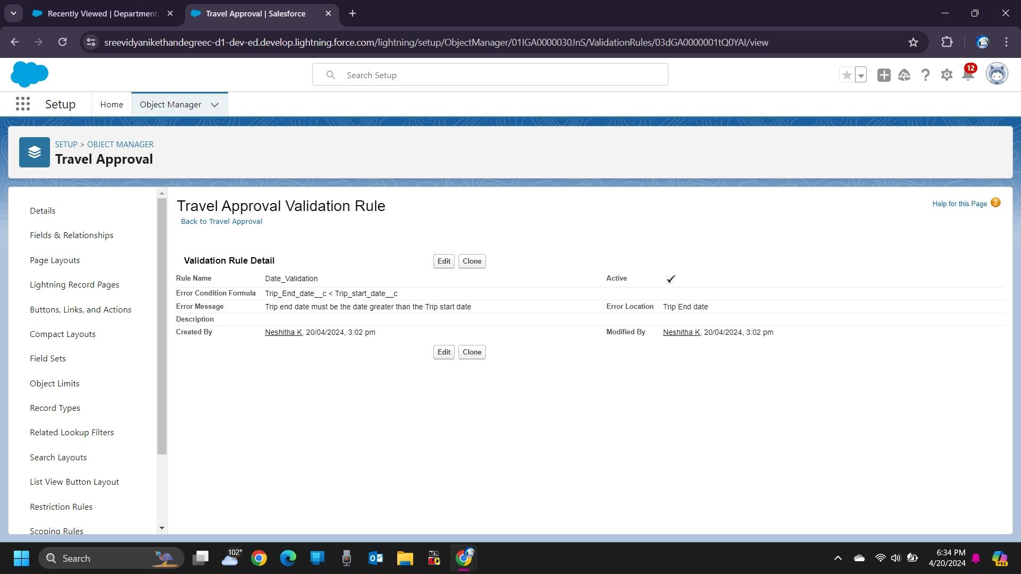

**Create Record**

Click App Launcher and select Travel Approval App

1)Click reports tab

2)Click New Report.

3)Click the report type as Travel approval with Departments Click Start report.

4)Customize your report, in group rows select – Department Name

5)Click refresh

6)Click save and run

7)Give report name – Travel Approval Report

8)Click Save

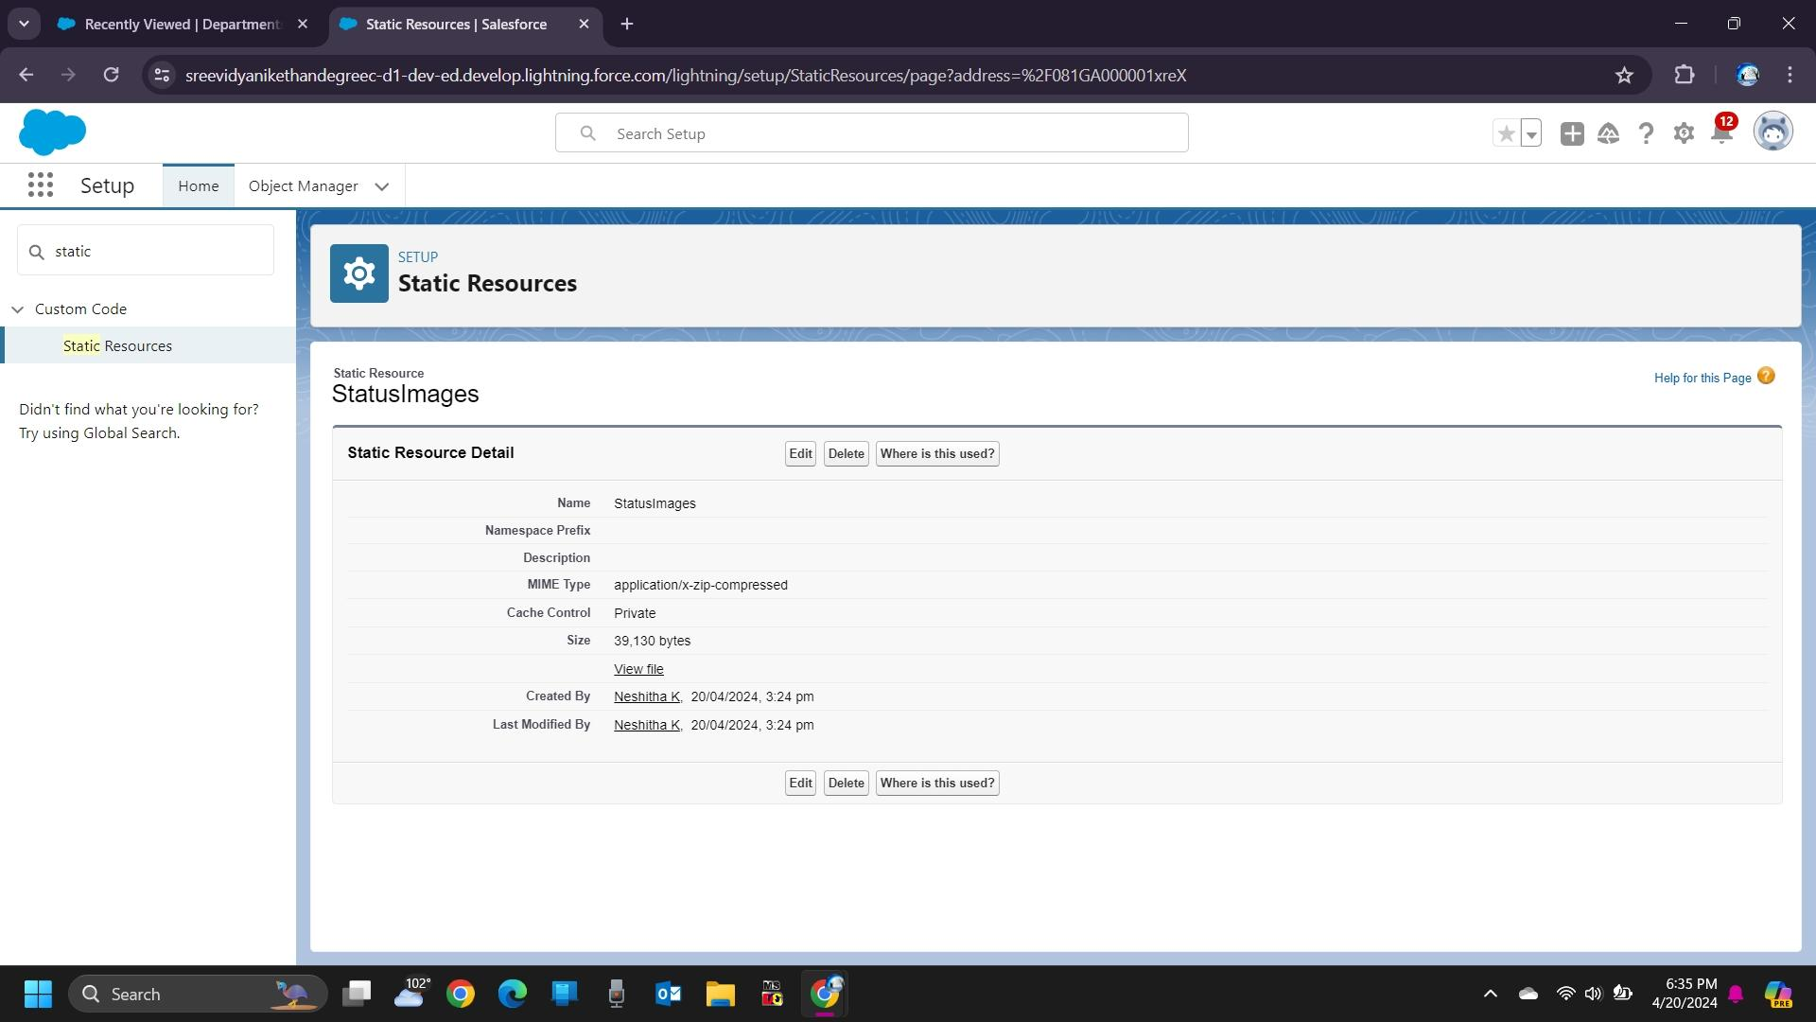

### **Create Report**

1. Click App Launcher and select Travel Approval App    
2. Click reports tab    
3. Click New Report.   
4. Click the report type as Travel Approval with Departments Click Start Report.   
5. Customize your report, in group rows select - Department Name   
6. Click Refresh   
7. Click save and run

8. Give report name – Travel Approval Report   
9. Click Save

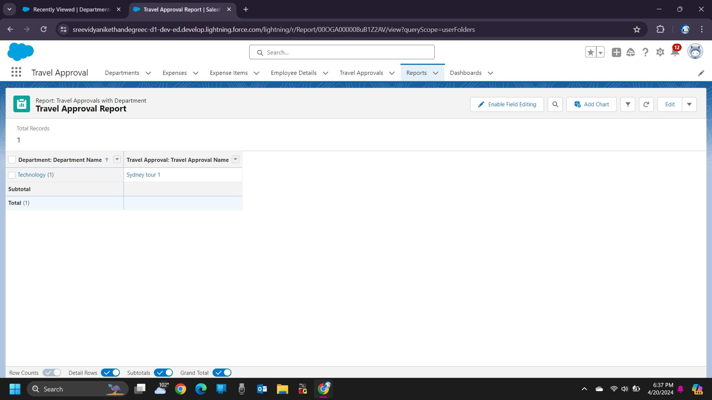

**CREATE DASHBOARD**

1. Click on the Dashboards tab from the travel approval application,
2. Click on a new dashboard
3. Give name- Travel Approval
4. Click Create
5. Give your dashboard a name and click on +component,
6. Select the Travel Approval Report that you created.
7. For the data visualization select any of the chart, table etc as your wish.
8. Click add
9. Click save.

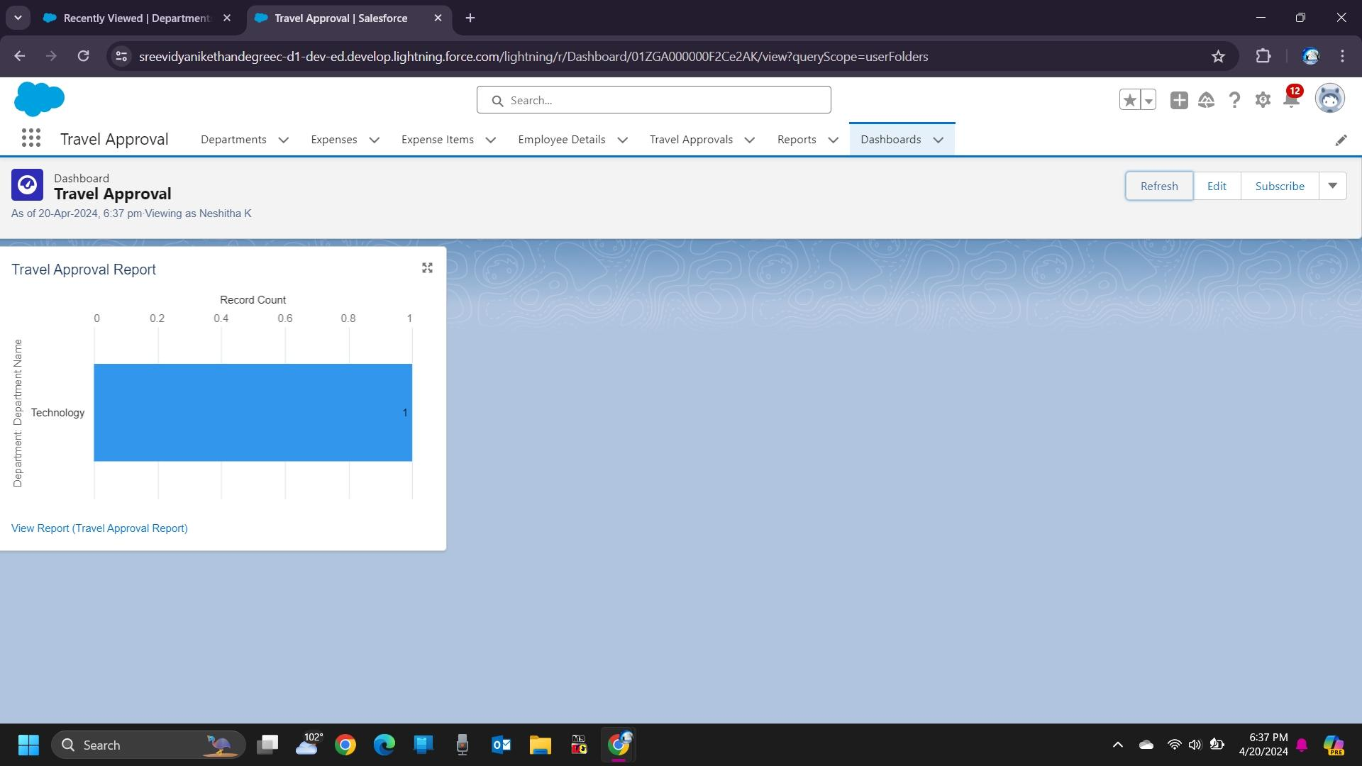

**Create A Flow**

Now, create a flow that uses the update record node to set the out-of-state flag.

1. From Setup, click the Home tab.

2. Select Process Automation | Flows (or use the Quick Find and search for flows)

3. Click New Flow.

4. Select Record-Triggered Flow then click Create.

5. Enter the values

6. Click Done.

7. In the Layout dropdown, select Freeform.

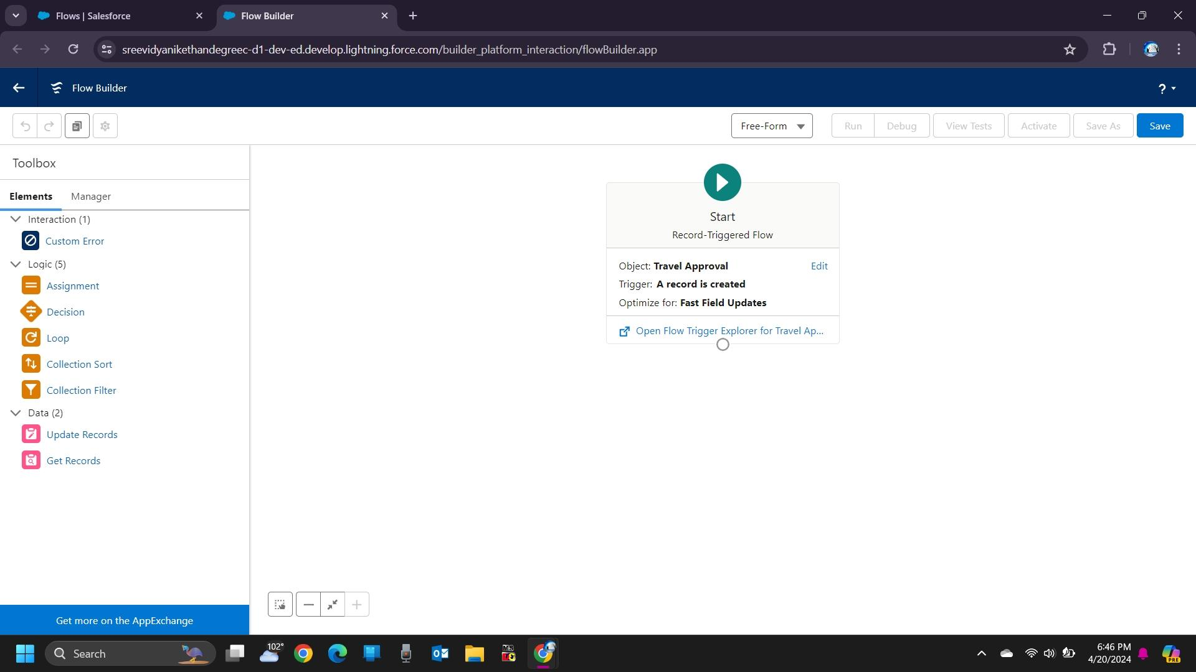

**Create An Approval Process**

Let’s get started.

1. Click and select Setup.

2. Select Process Automation | Approval Processes (or use the Quick Find and search for Approval Processes).

3. In the Manage Approval Processes For list, select Travel Approval.

4. Click Create New Approval Process and select Use Jump Start Wizard.

5. Enter the following parameters

6. Click Save.

7. Click View Approval Process Detail Page.

Notice in the Approval Steps section that it already created a rule to route all approvals to a user’s manager.

**Create an Approval Step for Out-of-State Travel**

Now, let’s create another approval step to send out-of-state travel to a travel coordinator.

1. Click New Approval Step.

2. Enter the following details

4. Ensure Enter this step if the following is selected and the criteria are met option is selected.

5. Enter the following formula criteria

Field: Travel Approval: Out-of-State

Operator: equals

Value: True

6. Click Next.

7. Select the automatically assign to the approver(s) option.

8. Select User from the dropdown and select your name as the travel coordinator. NOTE: In the real world, a user would not be selected as an approver of their own request. Salesforce demo orgs are limited to two Salesforce users. For this project, just use your user account for the travel coordinator.

9. Click Save.

